Step1

Create a package

griddemo

and add the

GridTest.java file

Step 2

Start the hub and node

Step 3

Testng.xml file which will require us to setup the port and the ip addresses where we want to execute the tests

Step 4

Run the testng suite from xml – it will fire the appropriate tests on the respective nodes

**Step 2 details are below**

Create a folder in either c or d drive

C:\griddemo

Copy the selenium jar file in this griddemo folder

**Open command prompt**

**Cd to the folder**

.Cd C:\griddemo

**Run the Hub Command**

java -jar selenium-server-standalone-2.53.1.jar -role hub

**it will start the hub**

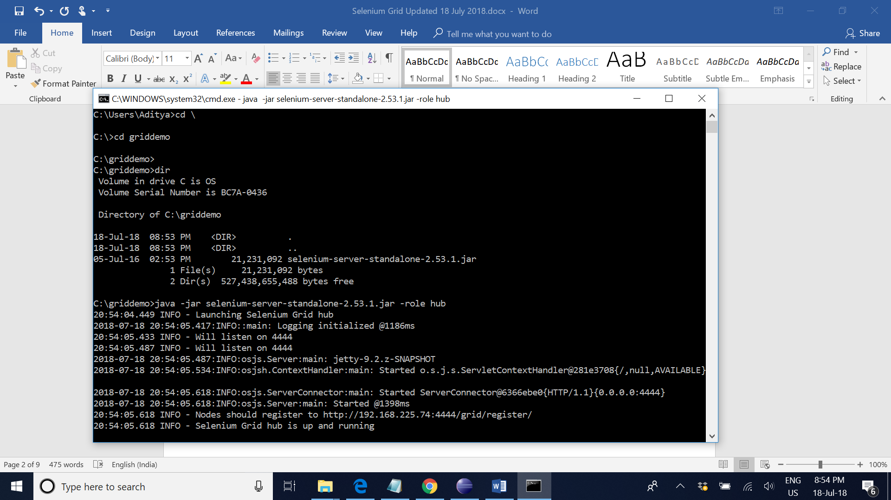

2018-07-18 20:54:05.618:INFO:osjs.ServerConnector:main: Started ServerConnector@6366ebe0{HTTP/1.1}{0.0.0.0:4444}

2018-07-18 20:54:05.618:INFO:osjs.Server:main: Started @1398ms

20:54:05.618 INFO - Nodes should register to http://192.168.225.74:4444/grid/register/

20:54:05.618 INFO - Selenium Grid hub is up and running

http://192.168.0.106:4444/grid/register/

**From the command prompt get the ipaddress**

http://192.168.225.74:4444/grid/register/

…………..

You can go to any browser and also check if the hub is up and running or not

<http://192.168.225.74:4444/>

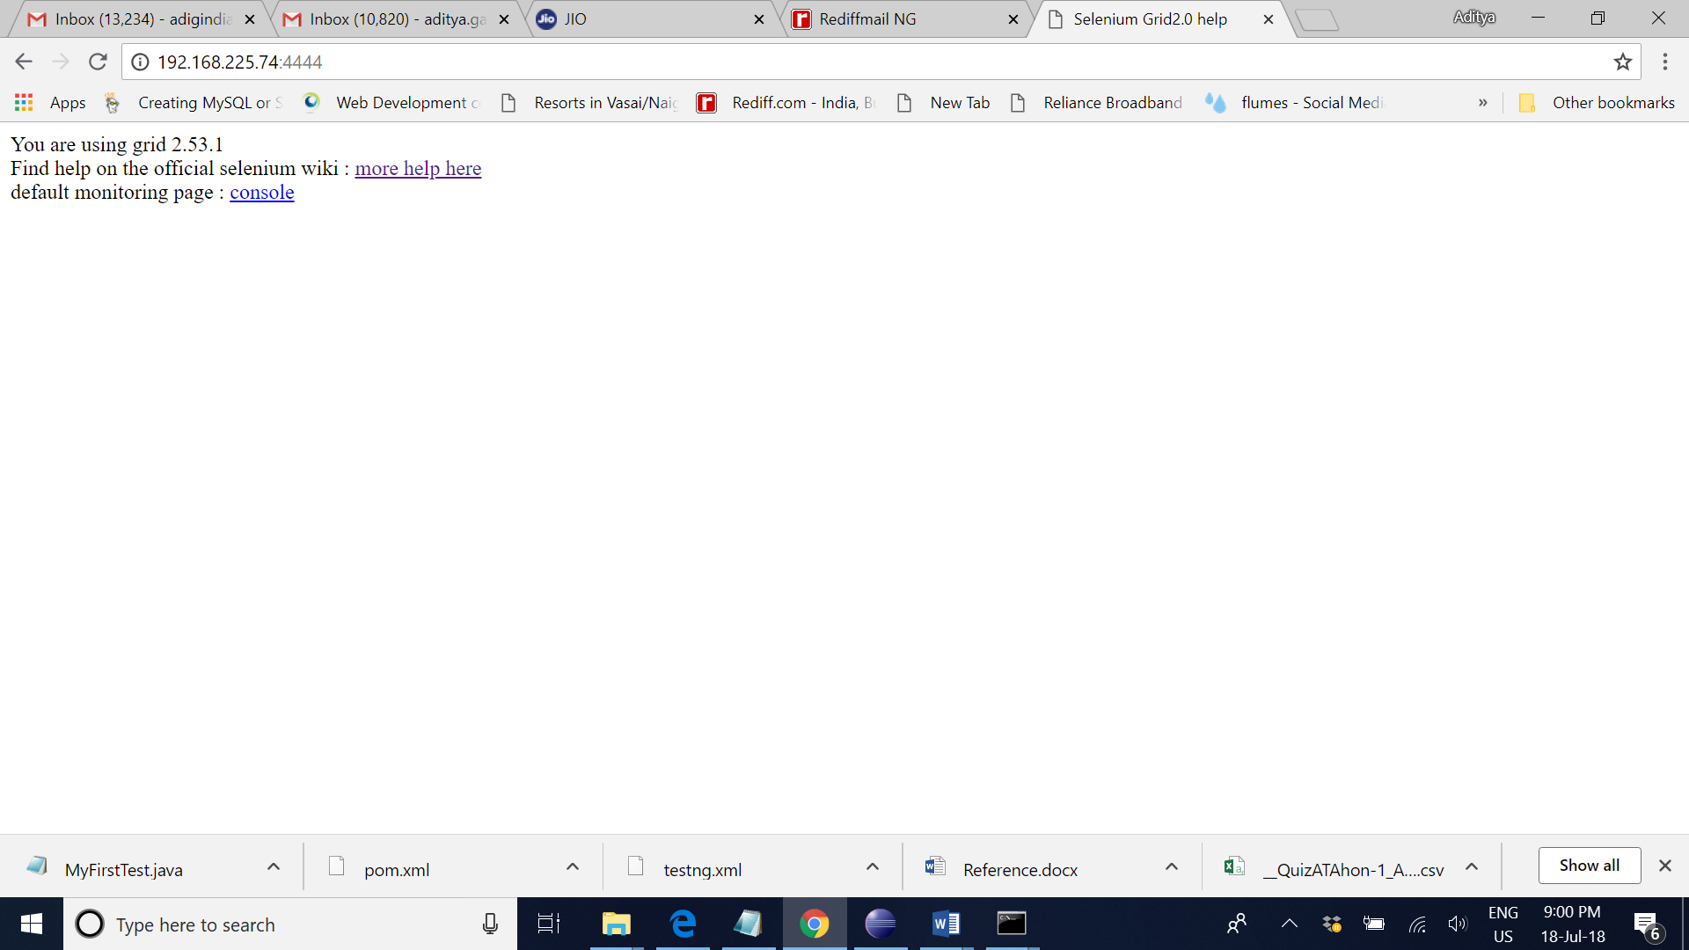

<http://192.168.225.74:4444/grid/console>

**now run the node command**

**node 1 chrome**

java -jar selenium-server-standalone-2.53.1.jar -role node -hub <http://192.168.225.74:4444/grid/register/> -port 5555 -browser browserName="chrome",version=ANY,platform=WIN10,maxInstances=5 -Dwebdriver.chrome.driver=C:\CP-SAT_Lab\Chromedriver\chromedriver.exe

remember to put the correct ip address

http://192.168.0.106:4444/grid/register/

java -jar selenium-server-standalone-2.53.1.jar -role node -hub <http://192.168.0.106:4444/grid/register/> -port 5559 -browser browserName="chrome",version=ANY,platform=WIN10,maxInstances=5 -Dwebdriver.chrome.driver=C:\griddemo\chromedriver.exe

**remember to change the port number if we want to use multiple nodes**

**remember the chromedriver folder should not have space in its root folder structure**

**remember in above the ip address is that of the hub and port number is configurable. We have to give proper path to the chrome driver**

**node 2 firefox**

java -jar selenium-server-standalone-2.53.1.jar -role node -hub http://192.168.225.74:4444/grid/register/ -port 5555 -browser browserName="firefox",version=ANY

**Remember to use the correct ip address**

java -jar selenium-server-standalone-2.53.1.jar -role node -hub http://192.168.0.106:4444/grid/register/ -port 5555 -browser browserName="firefox",version=ANY

**IF FIREFOX ONE IS NOT STARTING – PLEASE GIVE THE PROPER PATH**

Java -jar selenium.jar -Dwebdriver.firefox.bin="

capabilities.setCapability(FirefoxDriver.BINARY,"C:\\ff46\\firefox.exe");

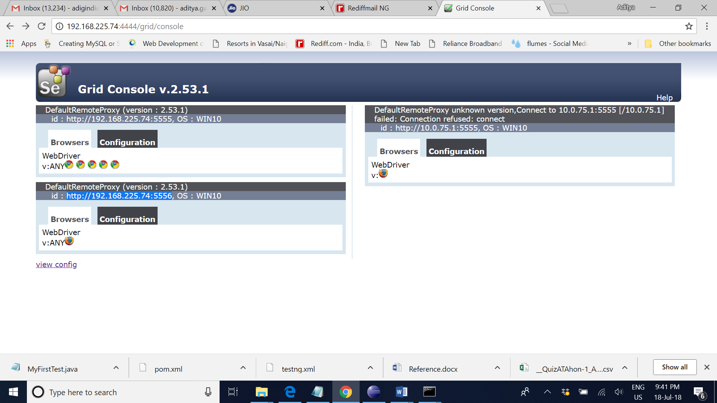

**Step 3 details are below**

**-**

**Create the .xml file to run two firefox tests based on the above registered information.**

**Note please change the ip address NOT as per the console but actual physical address**

<?xml version=*"1.0"* encoding=*"UTF-8"*?>

<!DOCTYPE suite SYSTEM "http://testng.org/testng-1.0.dtd">

<suite name=*"Suite"* parallel=*"tests"*>

<test name=*"TestFF"*>

<parameter name=*"browser"* value=*"firefox"*/>

<parameter name=*"port"* value=*"http://192.168.225.247:5555"*/>

<classes>

<class name=*"griddemo.GridTest"*/>

</classes>

</test>

<test name=*"TestFF2"*>

<parameter name=*"browser"* value=*"firefox"*/>

<parameter name=*"port"* value=*"http://192.168.225.74:5556"*/>

<classes>

<class name=*"griddemo.GridTest"*/>

</classes>

</test>

<test name=*"TestCH"*>

<parameter name=*"browser"* value=*"CHROME"*/>

<parameter name=*"port"* value=*"http://192.168.225.74:5555"*/>

<classes>

<class name=*"griddemo.GridTest"*/>

</classes>

</test>

</suite>

GridTest.java file

**package griddemo;**

**import static org.testng.AssertJUnit.assertEquals;**

**import org.testng.annotations.Test;**

**import java.net.MalformedURLException;**

**import java.net.URL;**

**import org.openqa.selenium.By;**

**import org.openqa.selenium.Platform;**

**import org.openqa.selenium.WebDriver;**

**import org.openqa.selenium.chrome.ChromeDriver;**

**import org.openqa.selenium.firefox.FirefoxDriver;**

**import org.openqa.selenium.ie.InternetExplorerDriver;**

**import org.openqa.selenium.remote.DesiredCapabilities;**

**import org.openqa.selenium.remote.RemoteWebDriver;**

**import org.testng.Assert;**

**import org.testng.annotations.AfterMethod;**

**import org.testng.annotations.AfterTest;**

**import org.testng.annotations.BeforeMethod;**

**import org.testng.annotations.Parameters;**

**import org.testng.annotations.Test;**

**public class GridTest {**

**static WebDriver driver = null;**

**@Parameters({"browser","port"})**

**@BeforeMethod**

**public void beforeTest(String browser, String port)**

**{**

**//compares the value of parameter name with Firefox, if its firefox then it will lauch firefox and run the script.**

**if (browser.equalsIgnoreCase("firefox"))**

**{**

**//driver = new FirefoxDriver();**

**// DesiredCapabilities.firefox();**

**DesiredCapabilities capabilities = DesiredCapabilities.firefox();**

**capabilities.setBrowserName("firefox");**

**capabilities.setPlatform(Platform.WIN8);**

**capabilities.setVersion("ANY");**

**try {**

**driver=new RemoteWebDriver(new URL(port.concat("/wd/hub")),capabilities);**

**} catch (MalformedURLException e) {**

**// TODO Auto-generated catch block**

**e.printStackTrace();**

**}**

**/*try {**

**driver=new RemoteWebDriver(new URL(port),capabilities);**

**} catch (MalformedURLException e) {**

**// TODO Auto-generated catch block**

**e.printStackTrace();**

**}*/**

**} else if (browser.equalsIgnoreCase("chrome"))**

**{**

**//System.setProperty("webdriver.chrome.driver","D:\\Selenium_Training\\chromedriver_win32\\chromedriver.exe");**

**//driver= new ChromeDriver();**

**DesiredCapabilities capabilities1 = DesiredCapabilities.chrome();**

**capabilities1.setBrowserName("chrome");**

**capabilities1.setPlatform(Platform.WIN8);**

**capabilities1.setVersion("ANY");**

**try {**

**driver=new RemoteWebDriver(new URL(port.concat("/wd/hub")),capabilities1);**

**} catch (MalformedURLException e1) {**

**// TODO Auto-generated catch block**

**e1.printStackTrace();**

**}**

**/*try {**

**driver=new RemoteWebDriver(new URL(port),capabilities);**

**} catch (MalformedURLException e) {**

**// TODO Auto-generated catch block**

**e.printStackTrace();**

**}*/**

**}**

**else if (browser.equalsIgnoreCase("ie"))**

**{**

**//System.setProperty("webdriver.ie.driver","D:\\Selenium_Training\\IEDriverServer_x64_2.51.0\\IEDriverServer.exe");**

**// driver= new InternetExplorerDriver();**

**DesiredCapabilities capabilities2 = DesiredCapabilities.internetExplorer();**

**capabilities2.setBrowserName("internet explorer");**

**capabilities2.setPlatform(Platform.WIN8);**

**capabilities2.setVersion("ANY");**

**try {**

**driver=new RemoteWebDriver(new URL(port.concat("/wd/hub")),capabilities2);**

**} catch (MalformedURLException e1) {**

**// TODO Auto-generated catch block**

**e1.printStackTrace();**

**}**

**/\***

**try {**

**driver=new RemoteWebDriver(new URL(port),capabilities);**

**} catch (MalformedURLException e) {**

**// TODO Auto-generated catch block**

**e.printStackTrace();**

**}*/**

**}**

**else**

**{**

**throw new IllegalArgumentException("The Browser Type is Undefined");**

**}**

**driver.get("https://www.wikipedia.org");**

**}**

**@Test**

**public void wiki() throws InterruptedException**

**{**

**driver.manage().window().maximize();**

**//Thread.sleep(5000);**

**driver.findElement(By.cssSelector("strong")).click();**

**//Thread.sleep(5000);**

**String expectedTitle = "Wikipedia";**

**// fetch the title of the web page and save it into a string variable**

**String actualTitle = driver.getTitle();**

**Thread.sleep(2000);**

**Assert.assertEquals(expectedTitle,actualTitle);**

**}**

**@AfterMethod //this annotation would run once test script execution would complete**

**public void afterTest()**

**{**

**try {**

**driver.wait(5000);**

**}**

**catch (Exception e){**

**driver.quit();**

**}**

**}**

**}**

**Testngport.xml**

<?xml version="1.0" encoding="UTF-8"?>

<!DOCTYPE suite SYSTEM "http://testng.org/testng-1.0.dtd">

<suite name="Suite" parallel="tests">

<test name="TestFF">

<parameter name="browser" value="firefox"/>

<parameter name="port" value="http://192.168.1.100:5555"/>

<classes>

<class name="Pkge.SeGrPortTest"/>

</classes>

</test>

<test name="TestCH">

<parameter name="browser" value="chrome"/>

<parameter name="port" value="http://192.168.1.100:5555"/>

<classes>

<class name="Pkge.SeGrPortTest"/>

</classes>

</test>

<test name="TestIE">

<parameter name="browser" value="ie"/>

<parameter name="port" value="5555"/>

<classes>

<class name="Pkge.SeGrPortTest"/>

</classes>

</test>

</suite>